SCHOOL OF COMPUTER SCIENCE AND ARTIFICIAL INTELLIGENCE |  |  |  |  | DEPARTMENT OF COMPUTER SCIENCE ENGINEERING
Program Name: B. Tech |  |  |  | Assignment Type: Lab |  |  | Academic Year:2025-2026
Course Coordinator Name |  |  |  | Venkataramana Veeramsetty
Instructor(s) Name |  |  |  | Dr. V. Venkataramana (Co-ordinator)  Dr. T. Sampath Kumar  Dr. Pramoda Patro  Dr. Brij Kishor Tiwari  Dr.J.Ravichander  Dr. Mohammand Ali Shaik  Dr. Anirodh Kumar  Mr. S.Naresh Kumar  Dr. RAJESH VELPULA  Mr. Kundhan Kumar  Ms. Ch.Rajitha  Mr. M Prakash  Mr. B.Raju  Intern 1 (Dharma teja)  Intern 2 (Sai Prasad)  Intern 3 (Sowmya)  NS_2 ( Mounika)
Course Code |  |  | 24CS002PC215 | Course Title |  | AI Assisted Coding
Year/Sem |  |  | II/I | Regulation |  | R24
Date and Day  of Assignment |  |  | Week9 - Tuesday | Time(s)
Duration |  |  | 2 Hours | Applicable to  Batches
AssignmentNumber:16.2(Present assignment number)/24(Total number of assignments)
 | Q.No. | Question |  |  |  |  |  | Expected Time  to complete
 | 1 | 1.1. Display all records from the employee’s table.  2. 2. Display only employee names and their departments.  3. 3. Show unique department names.  4. 4. Find employees with salary greater than 50000.  5. 5. Find employees from the IT department.  6. 6. Display employees hired after 2020.  7. 7. Show employees in ascending order of salary.  8. 8. Show top 3 highest-paid employees.  9. 9. Count total employees in the company.  10. 10. Find the average salary of employees.  11. 11. Find the highest and lowest salary.  12. 12. Find total salary expenditure per department.  13. 13. Display departments having more than one employee.  14. 14. Show average salary by department.;  15. 15. Count employees hired each year.  16. 16. List employees with their department locations.  17. 17. Find employees working in Bangalore.  18. 18. Display all employees even if they don’t belong to a department.  19. 19. Find departments with no employees.  20. 20. Count employees in each department.  21. 21. Find employees earning above average salary.  22. 22. Find the department with the highest average salary.  23. 23. Find employees hired most recently.  24. 24. Find employees earning the second highest salary.  25. 25. Find all employees in the same department as 'Amit Sharma'.  26. 26. Increase salary by 10% for IT employees.  27. 27. Change department of employee 'Ravi' to Marketing.  28. 28. Delete employees with salary below 40000.  29. 29. Add a new column 'email' to employees.  30. 30. Update email IDs for all employees.  31. 31. Find top 2 departments by average salary.  32. 32. Find how many employees work in each city.  33. 33. Show employee count and total salary together.  34. 34. Display employees with names starting with 'A'.  35. 35. Display employees whose last name ends with 'a'.  36. 36. Find employees hired in 2020.  37. 37. Show number of days since each employee was hired.  38. 38. Display employee names in uppercase.  39. 39. Concatenate first and last names.  40. 40. Find employees whose salary is between 45000 and 60000.  41. 41. Create a view for high salary employees (>55000).  42. 42. Display all records from the view.  43. 43. Add NOT NULL constraint to department name.  44. 44. Drop the view.  45. 45. Rename the employees table to staff.  46. 46. Create a backup copy of the employees table.  47. 47. Delete all data but keep the structure.  48. 48. Drop the employees backup table.  49. 49. Create an index on employee last name.  50. 50. Drop the index. |  |  |  |  |  | Week9 - Monday

Employee Table
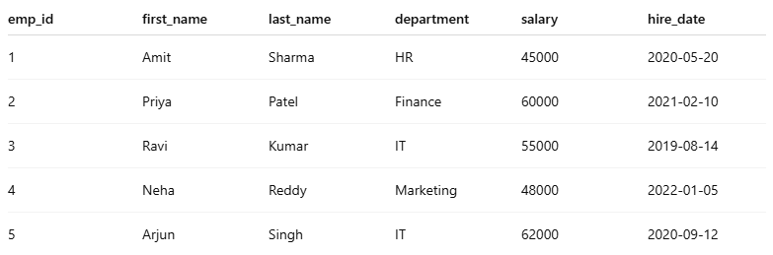

Department Table

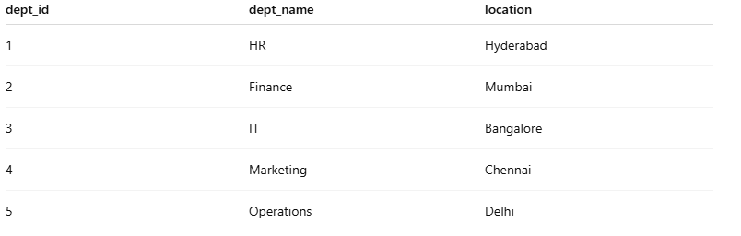

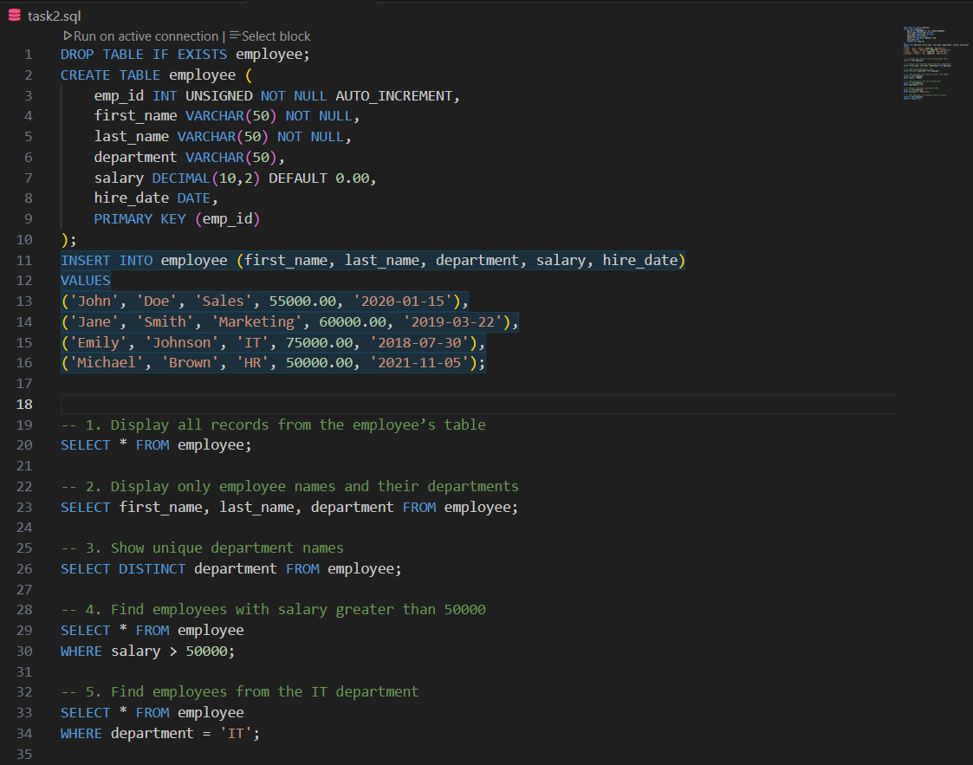
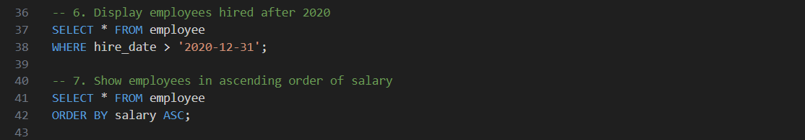

OUTPUTS:
1.1:
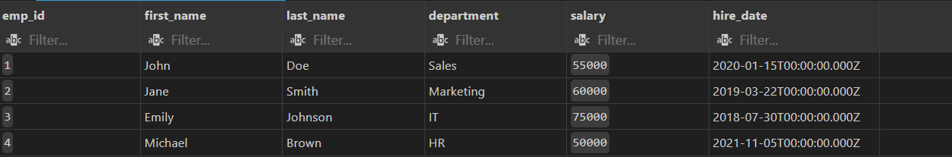

2.2
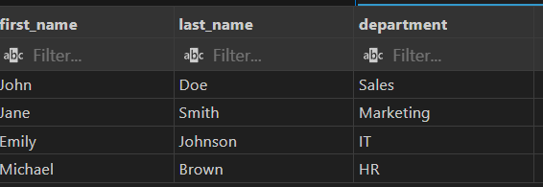

3.3:
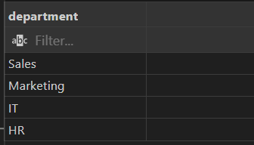

4.4:
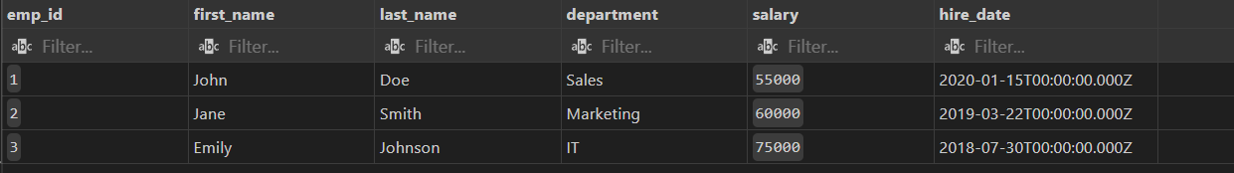

5.5:

6.6:

7.7:
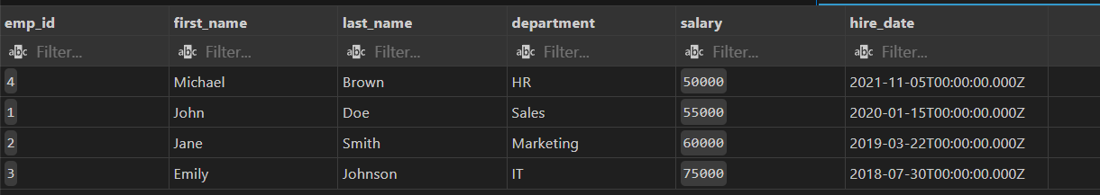

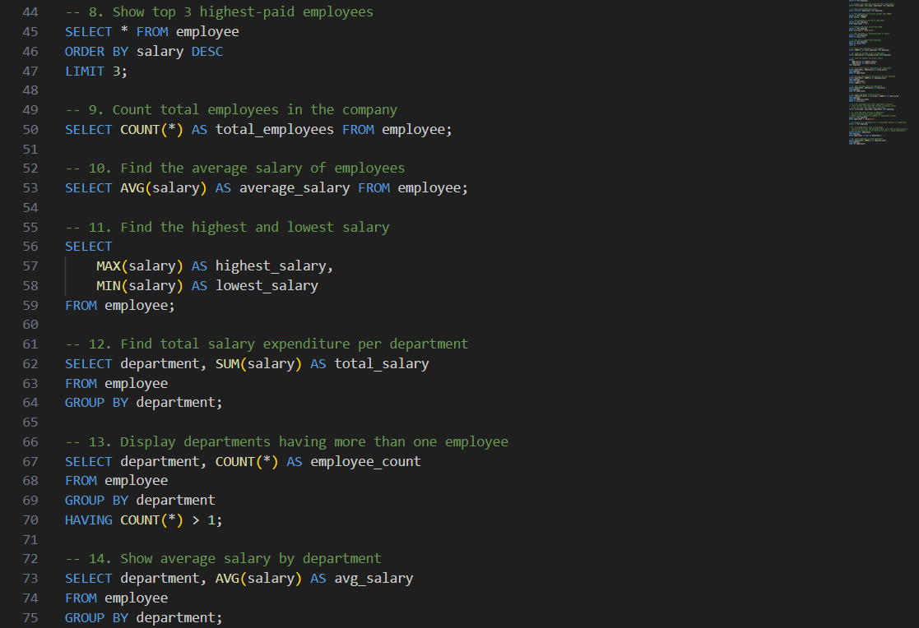
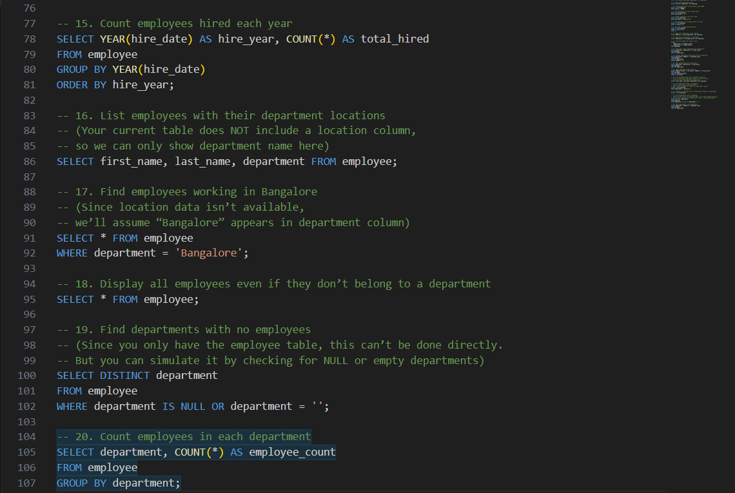

OUTPUTS:

8.8:
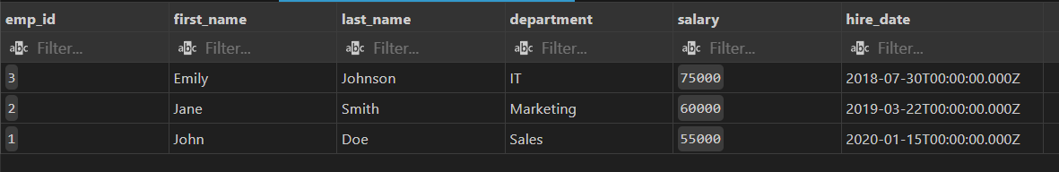

9.9:
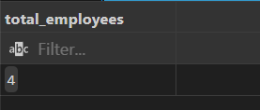

10.10:
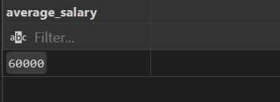

11.11:
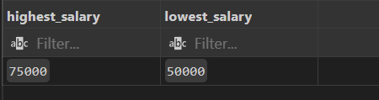

12.12:
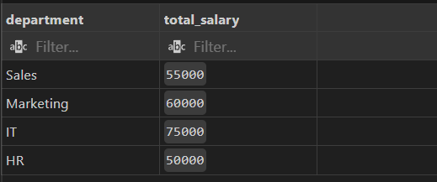

13.13:
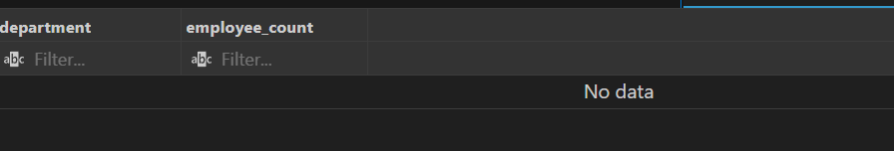

14.14:
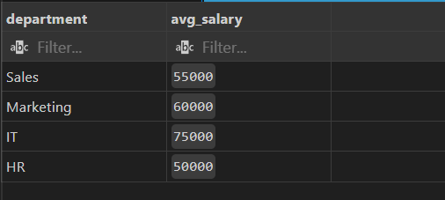

15.15:
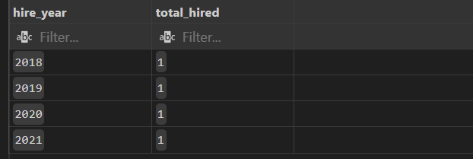

16.16:
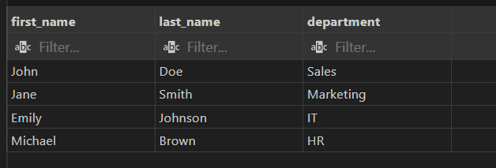

17.17:
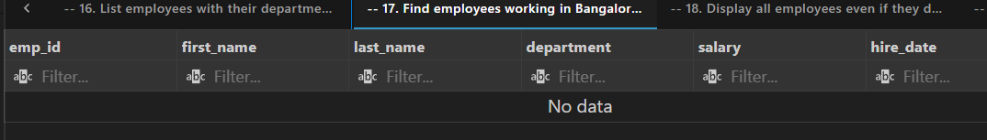
18.18:
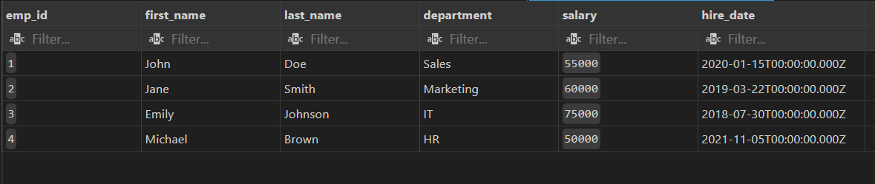

19.19:

20.20:
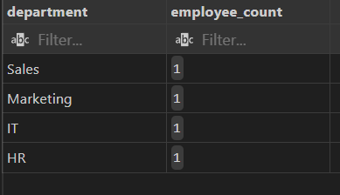

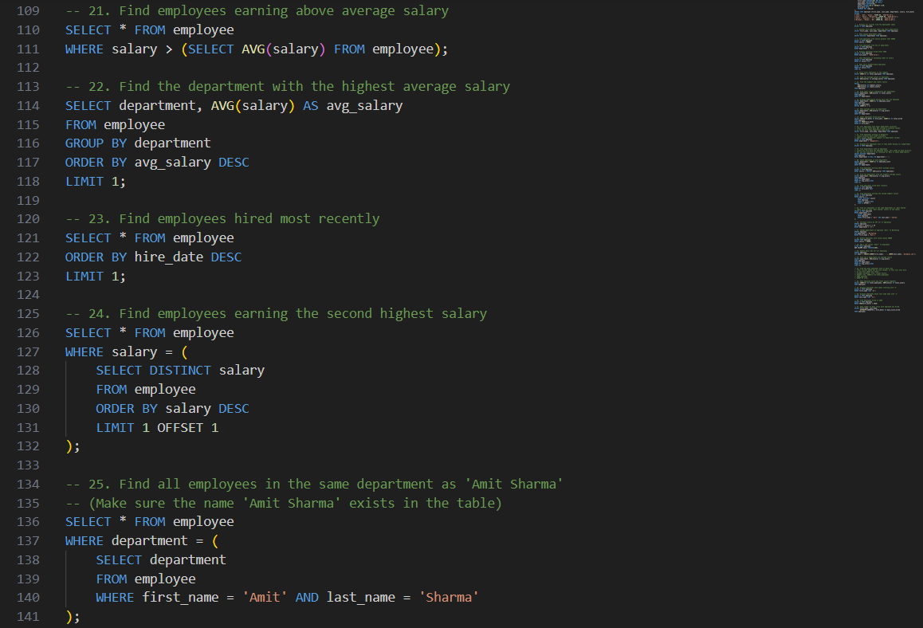
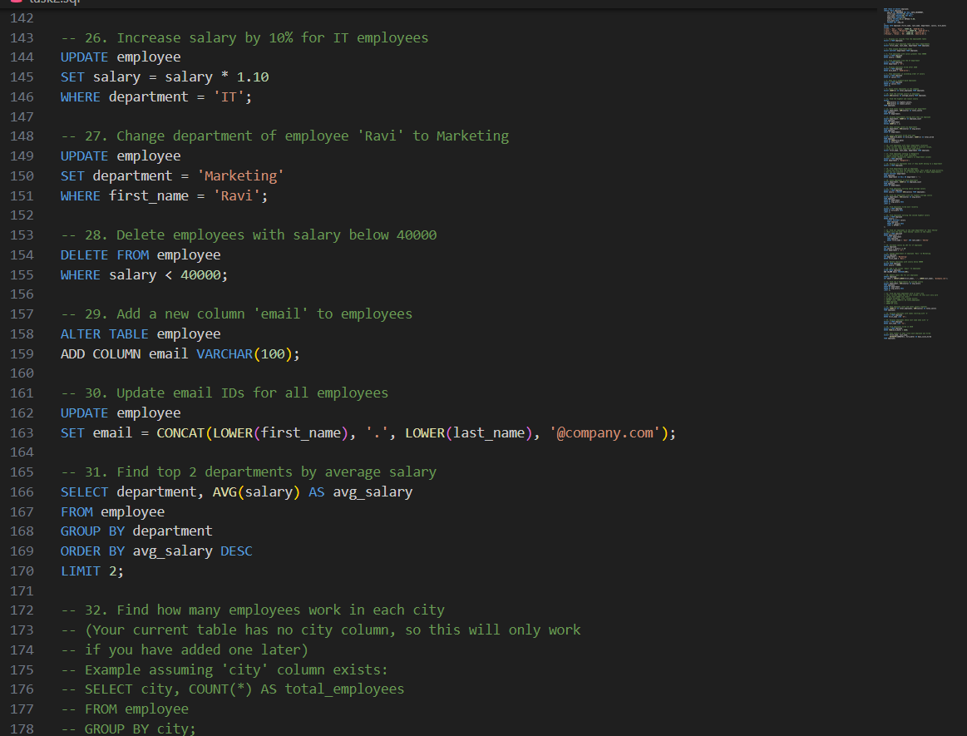
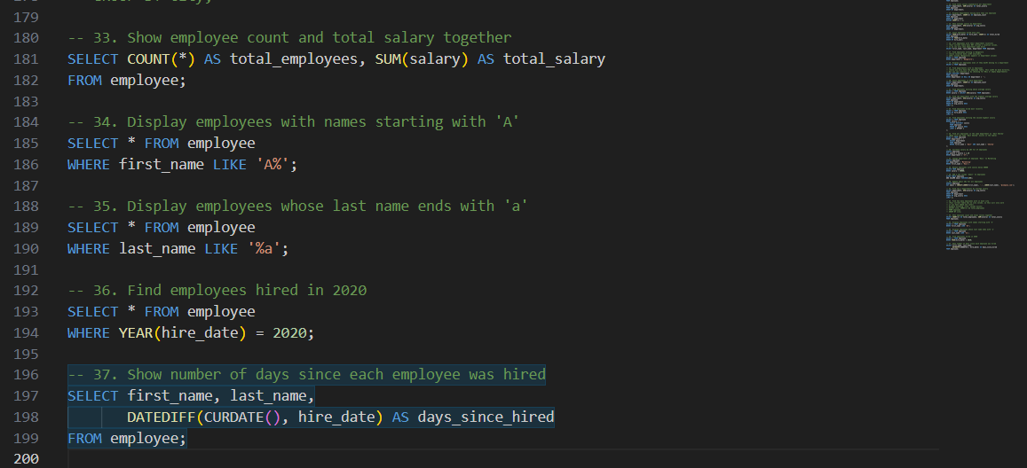

OUTPUTS:

21.21:
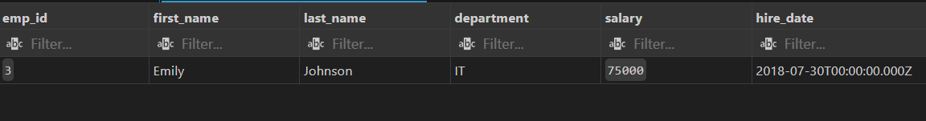

22.22:
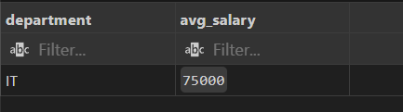

23.23:
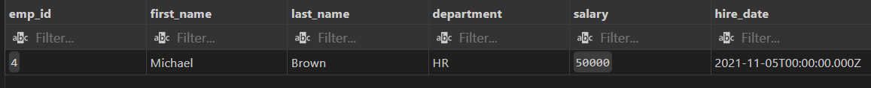

24.24:

25.25:

27.27:
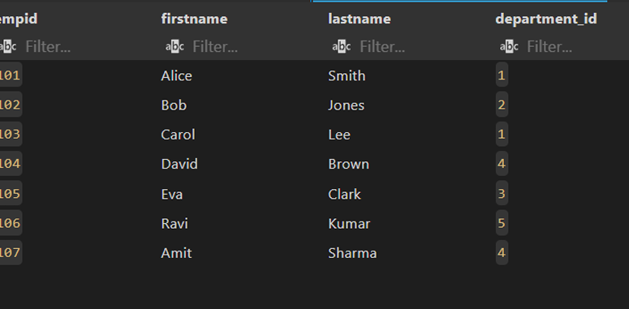

31.31:
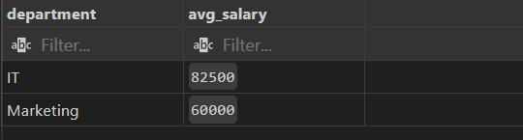

32.32:
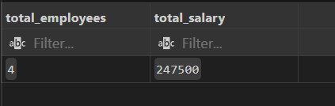

34.34:

35.35:
36.36:

37.37:
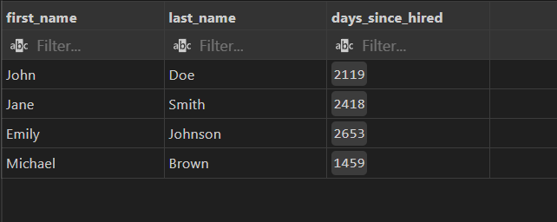

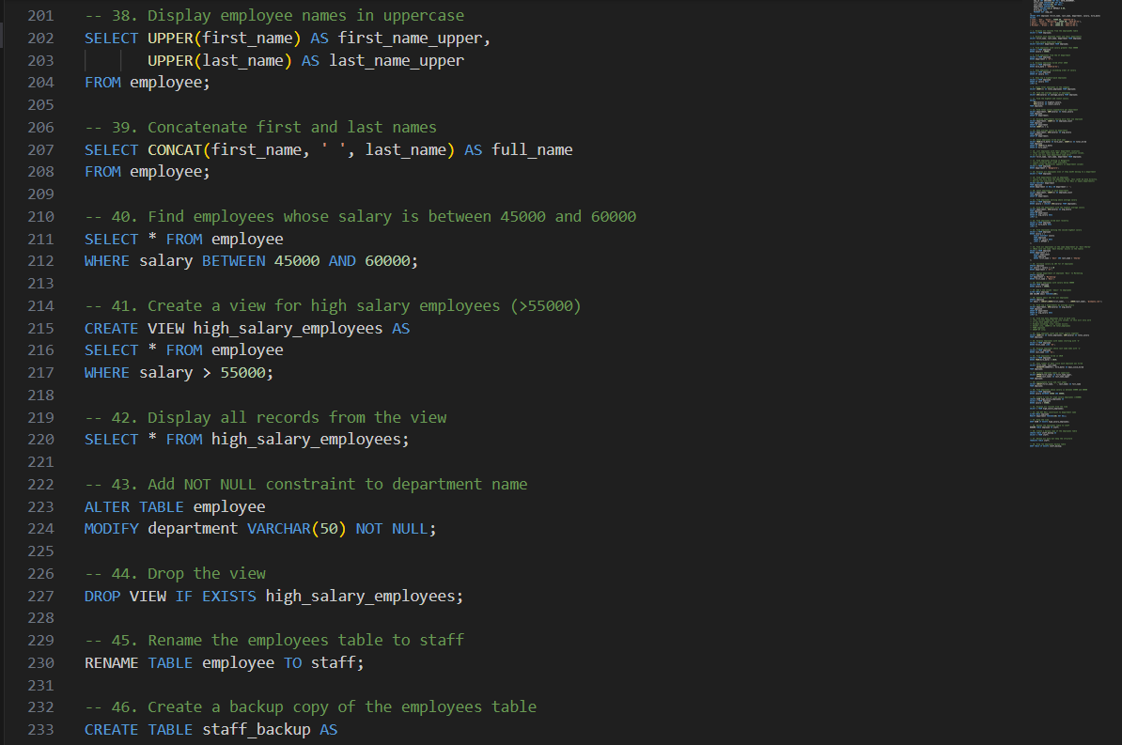
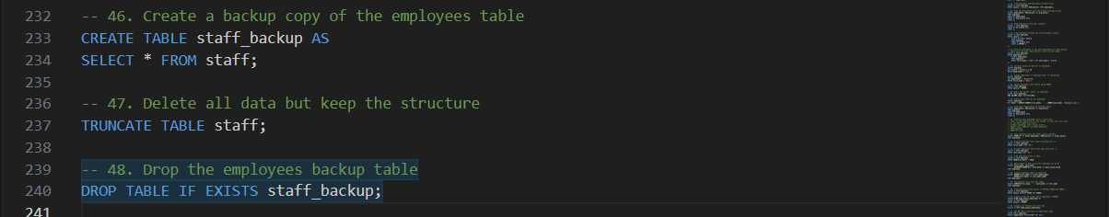
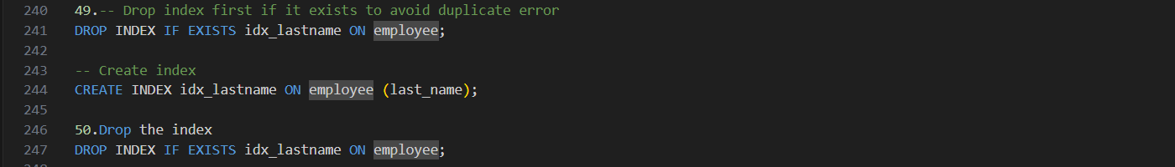

38.38:
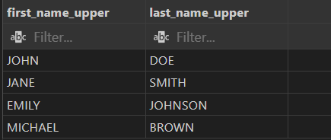

39.39:
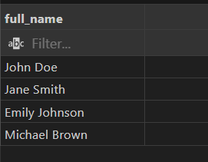

40.40:
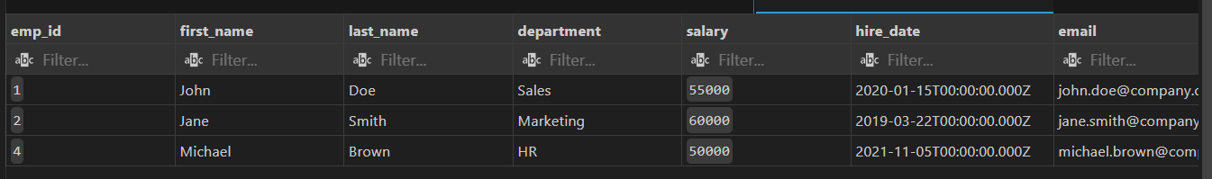

42.42:
